4600 South Redwood Road
Salt Lake City, UT 84123

April 5, 2019

Adam,

Thank you for applying for the Research and Grant Development Program. It is our pleasure to inform you that you have been selected as a SoTL Fellow. A committee of faculty and staff scored applications based on criteria aligned with the solicitation, and they found your proposal deserving.

As a next step, we would like to schedule a meeting to sit down and talk through your project, including the award amount, timeline, and expected outcomes. If your Outlook calendar is up-to-date, we will go ahead and send you an invite in the coming days. Also, we will be having a kick-off event for the Program awardees on April 12th. Please watch your email for the invitation.

We would also like to publicly acknowledge this recognition. We will most likely provide an announcement in SLCC Today. Thanks again for your strong proposal and interest in furthering innovation and research at the College. We look forward to supporting your project.

Sincerely,

Nicole Omer, Director, Office of Sponsored Projects
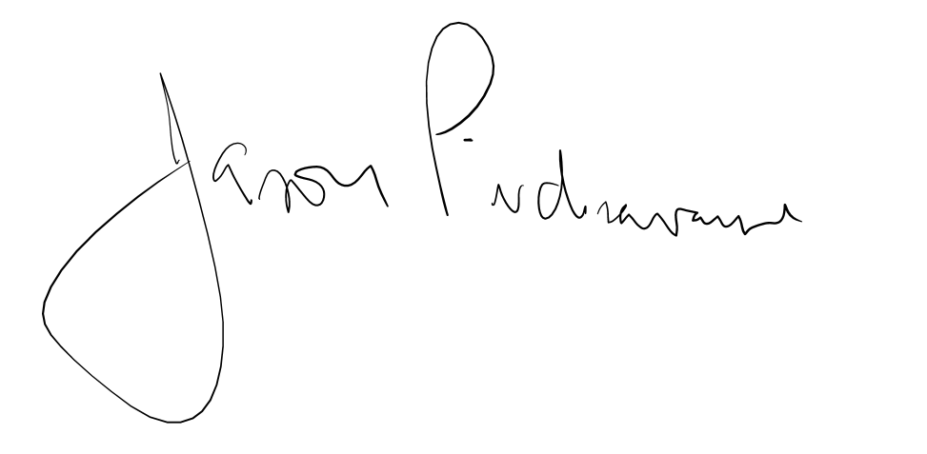
Jason Pickavance, Director, Faculty Development

